Case 2-Afr-Egy-Amulet-Hathor-Faience- Late Period, ca. 716-30 BCE

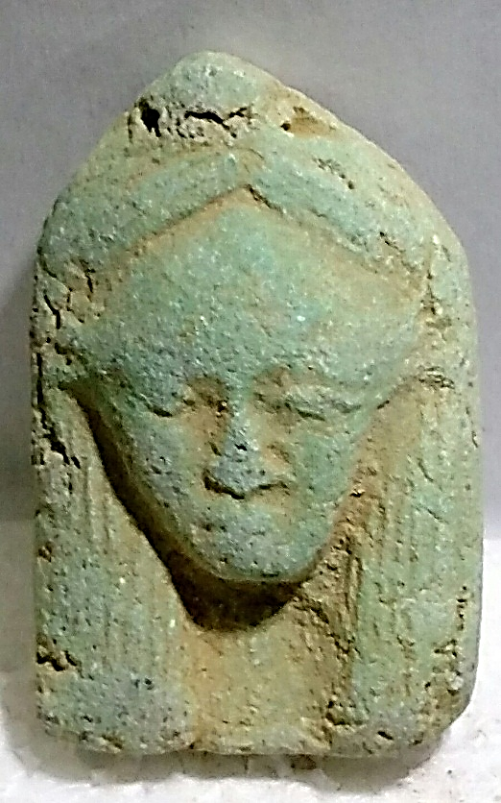 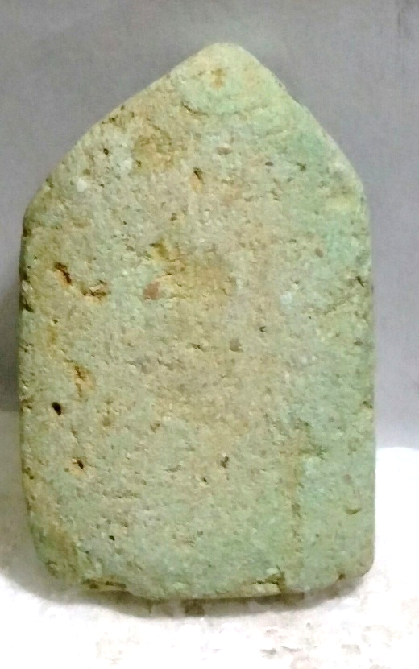

Afr-Egy-Amulet-Hathor-Faience- Late Period, ca. 716-30 BC

**Case No.: 2**

**Accession Number:**

**Formal Label:** Afr-Egy-Amulet-Hathor-Faience- Late Period, ca. 716-30 BC

**Display Description:**

FAIENCE AMULET OF HATHOR. Egypt, Late Period, ca. 716-30 BC. The amulet of light turquoise faience finely molded with the head of the cow-eared goddess. Suspension loop lost.

**LC Classification:**

**Date or Time Horizon:**

**Geographical Area:**

**Map:**

**GPS Coordinates:**

**Cultural Affiliation:**

**Medium:**

**Dimensions**: H 45 mm    
**Weight:** 12.5 g,.

**Provenance:**

**Condition:**

**Discussion:**

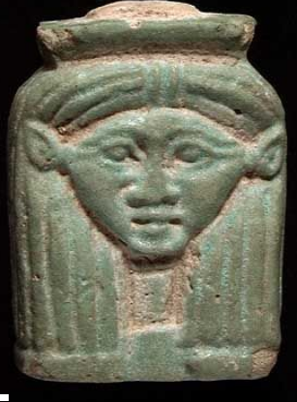

**References**